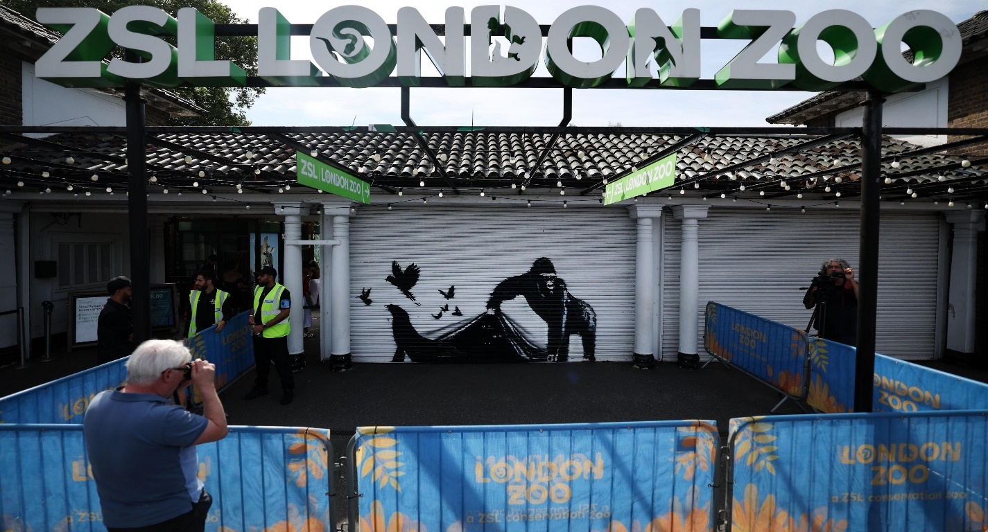

About Zsl London Zoo Park

What is Zsl London Park Zoo? and where is located established? ZSL London Zoo, located in Regent's Park, London, is the world's oldest scientific zoo, established in 1828. It is managed by the Zoological Society of London (ZSL),a charity dedicated to worldwide wildlife conservation.

Opening & Closed Timings

27 October 2024 - 19 January 2025 Open daily from 10:00 AM to 4:00

Last admission is one hour before closing. Some animal exhibits may close up to 30 minutes before closing time.

ZSL London Zoo offers various family-friendly events and activities throughout the year. Specific dates and times can be found on their official website by contacting the zoo directly.

There are no specific "Ladies' Days" listed in the zoo's schedule. For information on special events, it's best to check the zoo's official website or contact them directly.

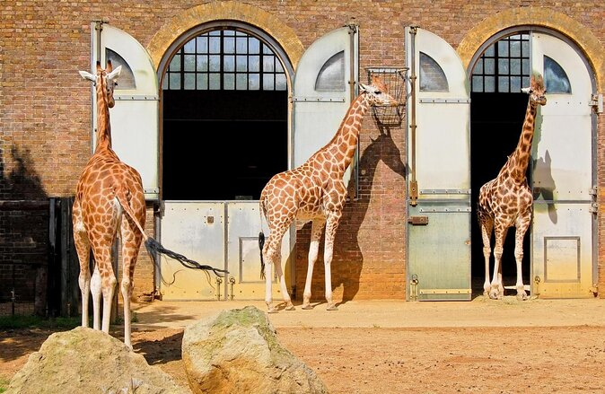

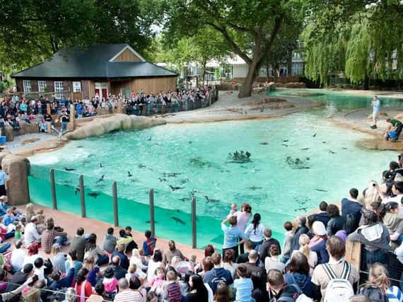

Animals List

The zoo is home to over 20,000 animals representing more than 750 Notable exhibits include:

Lions

Penguin

tigers

Reptiles

Crocodiles

Snakes

Gorillas

Lizard

Monkeys

Address & Contact

Address: ZSL London Zoo, Regent's Park, London, NW1 4RY, United Kingdom.

For questions related to visiting, opening times, directions, accessibility, or other general information, you can visit their [Support Centre](https://www.londonzoo.org/about-us/contact-london-zoo).

Email: For specific enquiries you can fill out the contact form available on their [website](https://www.londonzoo.org/about-us/contact-london-zoo).

Phone:For urgent enquiries, you can call their Supporter Contact team at 0344 225 1826. For the most accurate and up-to-date information, it's recommended to visit the [official ZSL London Zoo website](https://www.londonzoo.org/).